MSSV: 22002575

Họ tên SV: Trần Gia Nguyên Phong

Notes: Filename: HoTen_MSSV_Library.docx

**Lab09**

**Mapping**

**Exercises:**

1. Figure 7.8 shows an ER schema for a database that may be used to keep track of transport ships and their locations for maritime authorities. Map this schema into a relational schema, and specify all primary keys and foreign keys.[6 đ]

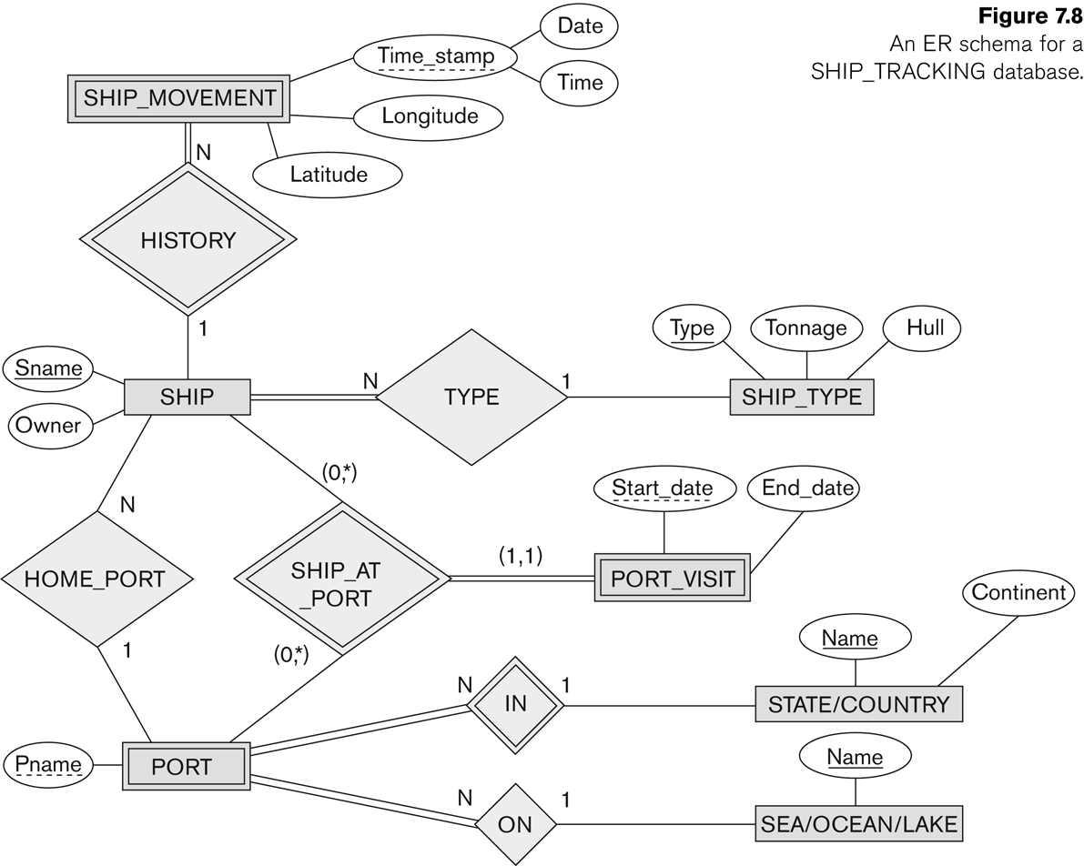

**Step By Step**

Step 1: Mapping of Regular Entity Types

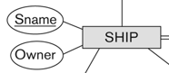

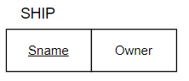

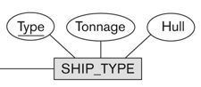

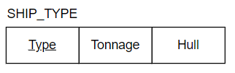

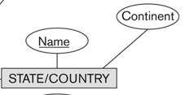

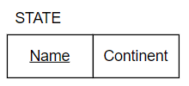

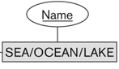

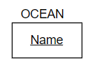

Step 2: Mapping of Weak Entity Types



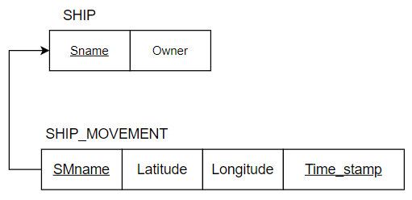



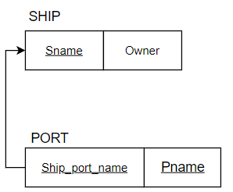

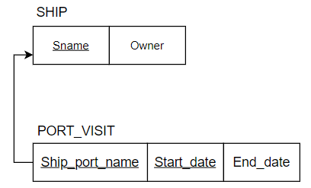

Step 3: Mapping of Binary 1:1 Relation Types



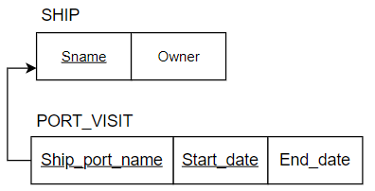

Step 4: Mapping of Binary 1:N Relationship Types.



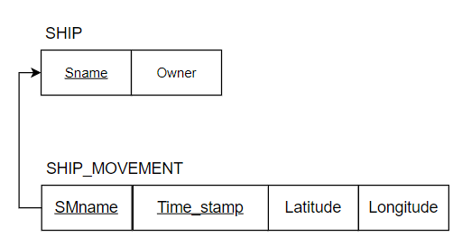



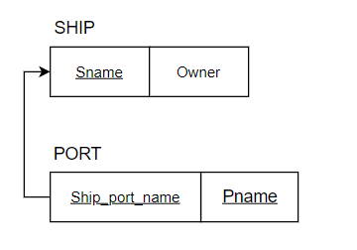



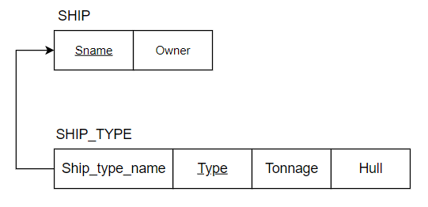



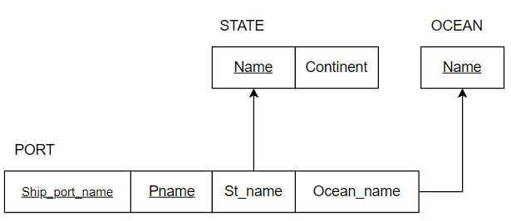

**Relational Diagram**

2. Map the BANK ER schema (shown in Figure 3.21) into a relational schema. Specify all primary keys and foreign keys.

Repeat for the AIRLINE schema (Figure 3.20) [2đ+2đ]

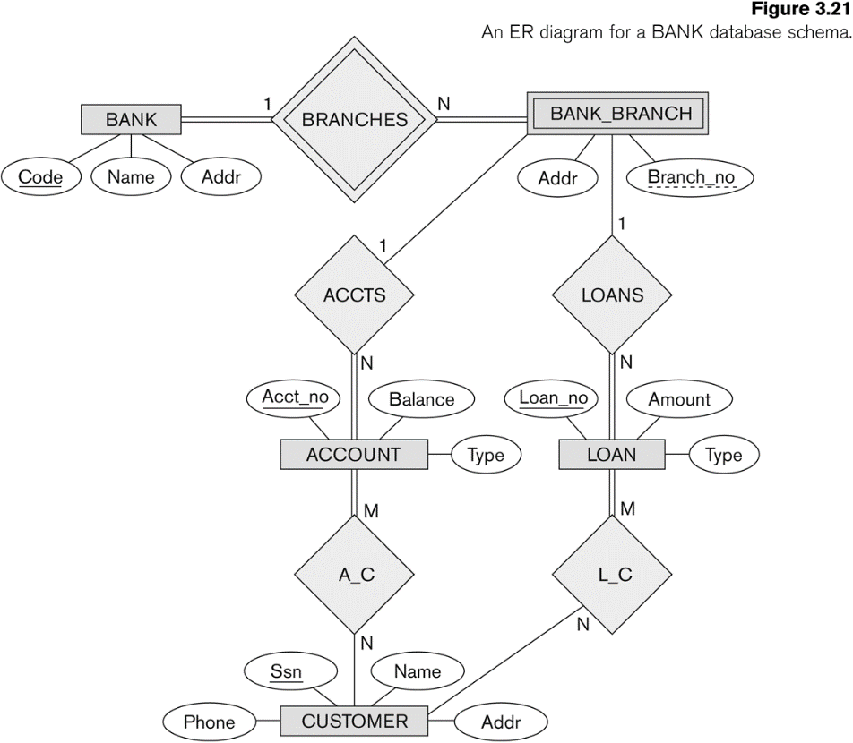

Step 5: Mapping of Binary M:N Relationship Types.







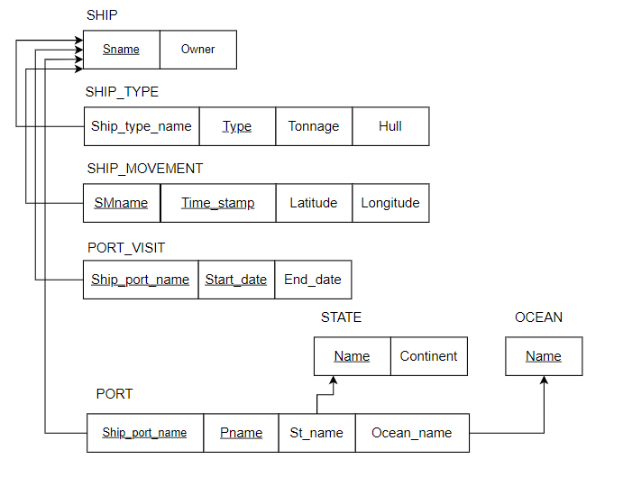

**Relational Diagram Only**

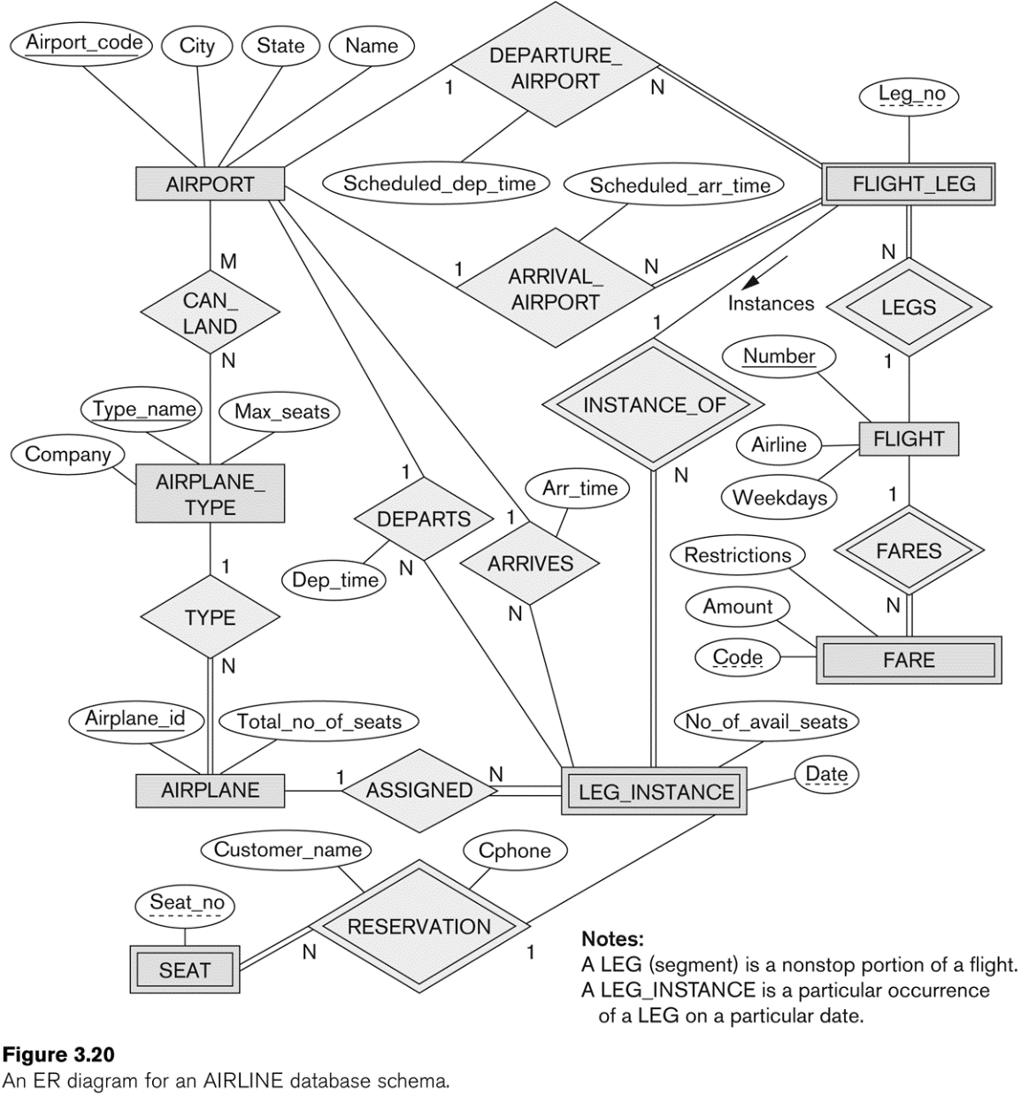

**Step By Step**

Step 1: Mapping of Regular Entity Types



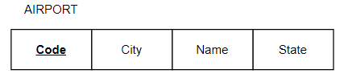



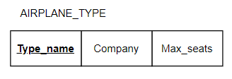



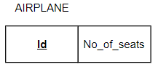



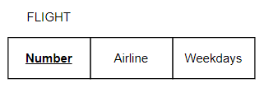

Step 2: Mapping of Weak Entity Types



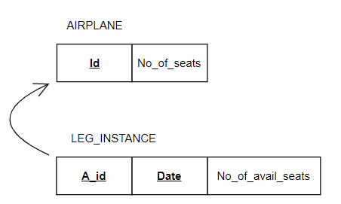



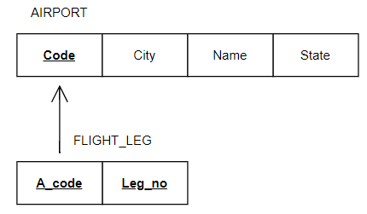

**Relational Diagram Only**

**HẾT**